January
2017
Nam id velit non risus consequat iaculis.

“For the soul of every living thing is in the hand of God”  - Job 12:10 | 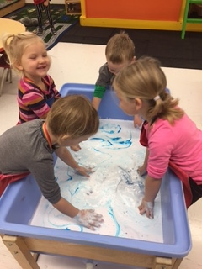

Sunday | Monday | Tuesday | Wednesday | Thursday | Friday | Saturday
1 | 2 | 3 | 4 | 5 | 6 | 7
Christmas Break ->
8 | 9 | 10 | 11 | 12 | 13 | 14
Animals | School Starts
15 | 16 | 17 | 18 | 19 | 20 | 21
Animals
22 | 23 | 24 | 25 | 26 | 27 | 28
Animals |  |  |  |  | School Closed
29 | 30 | 31
Animals

