December
2016
Nam id velit non risus consequat iaculis.

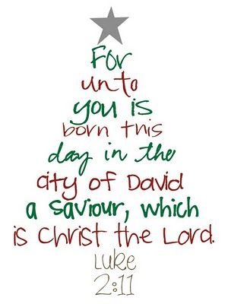 | 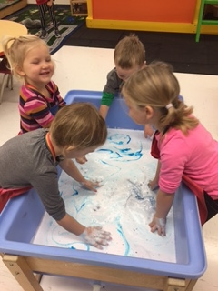

Sunday | Monday | Tuesday | Wednesday | Thursday | Friday | Saturday
 |  |  |  | 1 | 2 | 3
Winter
4 | 5 | 6 | 7 | 8 | 9 | 10
Christmas |  |  |  |  | School Closed
11 | 12 | 13 | 14 | 15 | 16 | 17
Christmas
18 | 19 | 20 | 21 | 22 | 23 | 24
Christmas | Parent’s Coffee |  | PJ Day | School Concert | Christmas Break -> | Christmas Eve
25 | 26 | 27 | 28 | 29 | 30 | 31
Christmas Day | Boxing Day |  |  |  |  | New Years Eve

