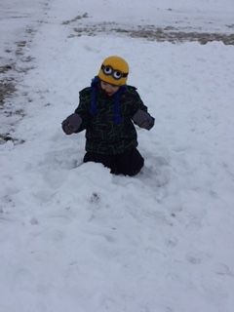

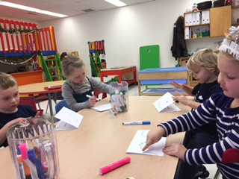

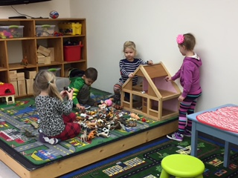

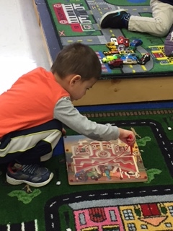

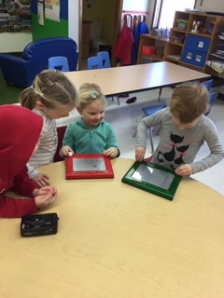

Some pictures of what we’ve been up to…

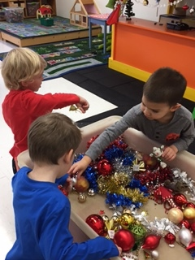

I hope you all had a wonderful Christmas, and a restful winter break.

Teacher:

Mollie Farley

403-872-4181

mollie.f@rimbeychristianschool.com

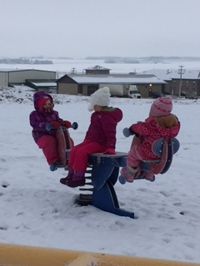

January

Show and Share

Mondays and Wednesdays

Upcoming Themes:

- Animals Around the World

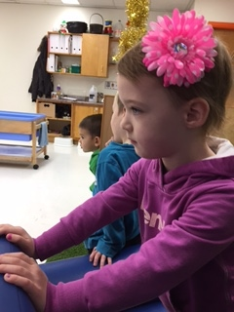

Fingerprints Playschool

Rimbey Christian School

4522 54 Ave, Rimbey AB

403-843-4790

[office@rimbeychrsitianschool.com](mailto:office@rimbeychrsitianschool.com)

www.rimbeychristianschool.com

Note from Teacher

December was spent talking about Christmas, what it is we celebrate, what the greatest gift of Christmas is, and how Christmas is not about what you get. We were also visited by a kindness elf, Herman. Herman gave us special jobs each day to show kindness at school and at home. We have also been enjoying playing horses, and creating beautiful works of art.