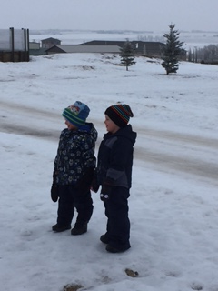

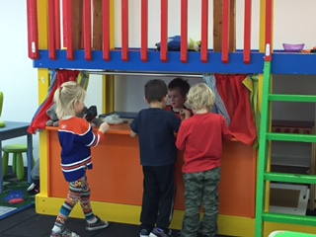

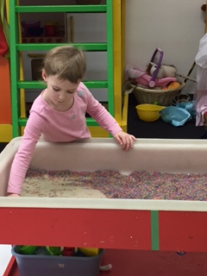

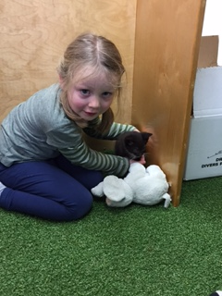

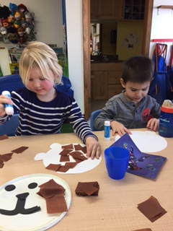

Some pictures of what we’ve been up to…

If you’re child only attends once a week and we are closed that day – they are welcome come the other day that week

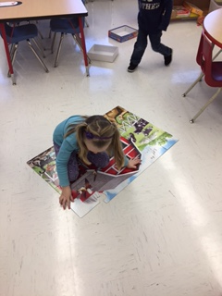

Teacher:

Mollie Farley

403-872-4181

mollie.f@rimbeychristianschool.com

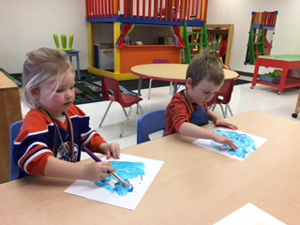

February

Show and Share

Mondays and Wednesdays

Upcoming Themes:

- Families / Valentine’s

- Dinosaurs

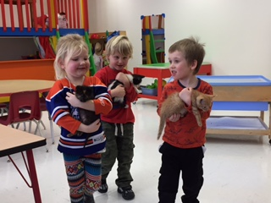

Fingerprints Playschool

Rimbey Christian School

4522 54 Ave, Rimbey AB

403-843-4790

[office@rimbeychrsitianschool.com](mailto:office@rimbeychrsitianschool.com)

www.rimbeychristianschool.com

Note from Teacher

We spent January talking about different animals around the world. We explored what animals live where it is hot, cold, in the forest, and that people keep as pets. We loved getting outside on the nice warm days, dressing up as animals, and spending time making different art projects.