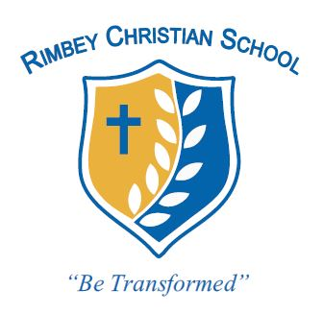
Rimbey Christian School

Monday | Tuesday | Wednesday | Thursday | Friday | Sat | Sun
26 | 27 | 28 | 29  Hot Lunch  Hamburger Soup | March 1 | 2 | 3
4  Boys Basketball  Prctice | 5  Celebrating 100 years of fashion –  Dress Retro! | 6  Boys Basketball game  In Lacombe | 7  Jr High going to Ponoka Chrisitan School  Rimbey Coldest Night Walk 7 P.M.  Start A CRC  5506 51 Ave | 8  PD Teachers only | 9/10  Medicine Lodge Ski hill open
11 | 12  VIP Meats  Orders come in | 13 | 14  Hot lunch  Pizza Buns | 15 | 16 |  | 17
18 | 19  Report Card Day | 20 | 21  Hot Lunch  Taco in a Bag  Parent Teacher  Interviews | 22  Closed in Lieu of P/T interviews | 23 |  | 24
25 | 26 | 27 | 28 | 29 | 30 |  | 31
April 1 | 2 | 3 | 4 | 5 | 6 |  | 7
8 | 9 | 10 | 11 | 12 | 13 |  | 14
March 2024
CALENDAR OF EVENTS
A schedule for you to know when your child will be eating:
10:30-11:00 | F i r s t N u t r i t i o n and Recess B r e a k
10:30-10:45 | Nutrition Break: Everyone has snack,
12:40-1:30 | S e c o n d N u t r i t i o n and Recess B r e a k
12:40- 1:00 | Nutrition Break: Everyone has lunch

